**Контрольная работа «Тест на переутомление (ортостатическая проба)»**

Критерии оценки:

* Наличие всех элементов интерфейса;
* Все элементы интерфейса рабочие;
* При нажатии кнопки происходит переключение на другое окно;
* Интерфейс содержит ассоциативное восприятие, соответствующее высокому и низкому уровню утомления;
* Программа одинаково выглядит на экранах с разных разрешением.

Демонстрация начального активити:

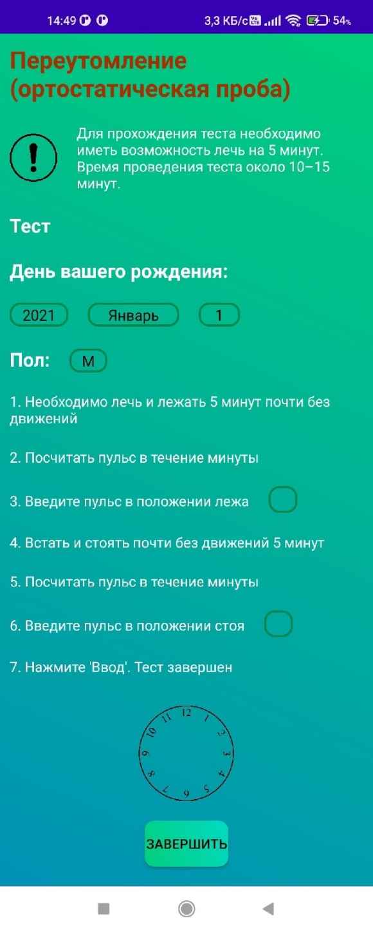

Демонстрация вешнего вида приложения с использованием другого разрешения, в данном случае использовался альбомный режим того же устройства: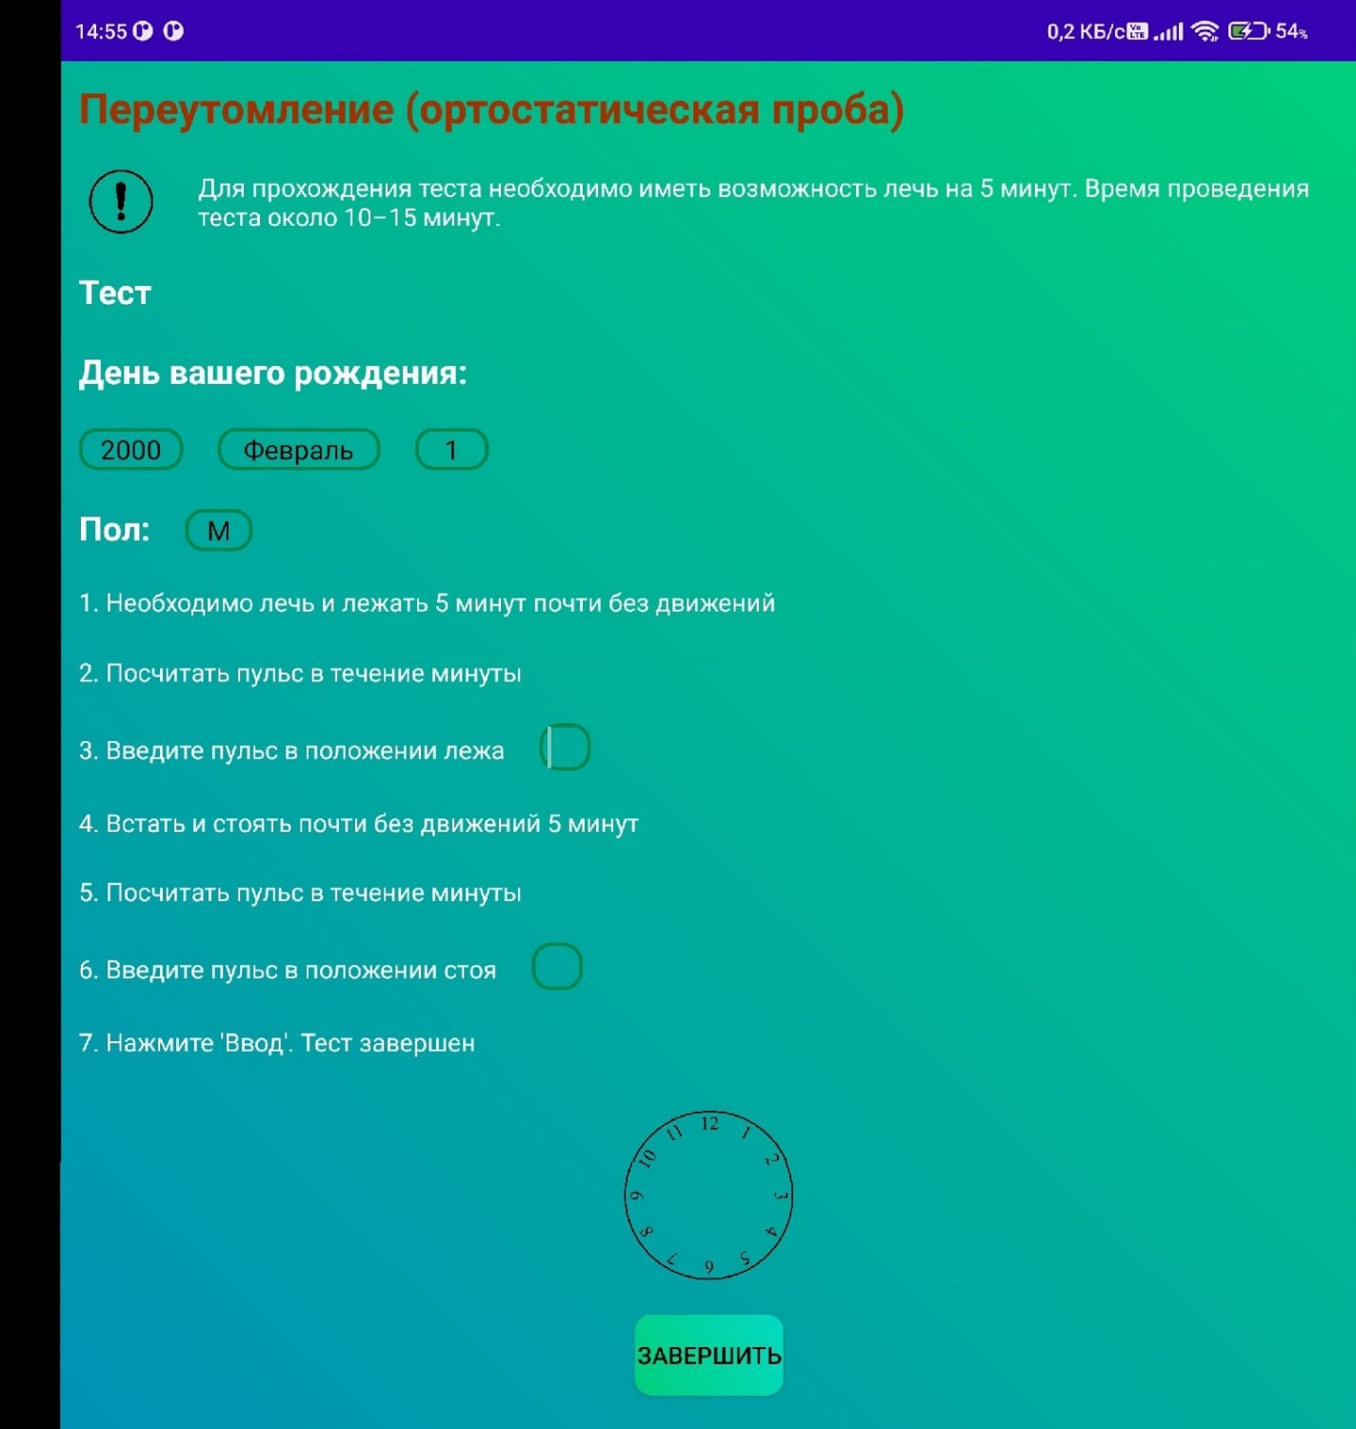

Демонстрация реализации безопасного ввода: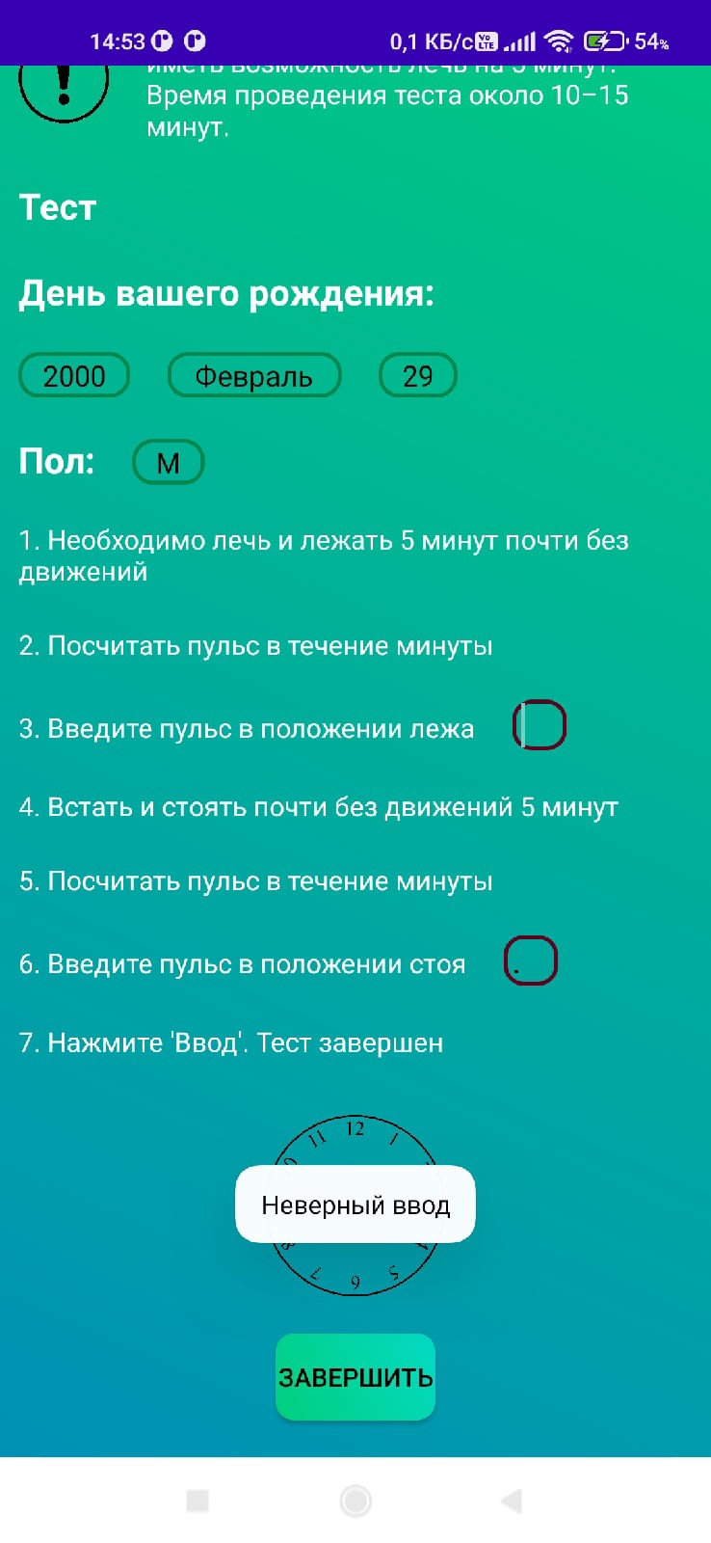

Демонстрация реализации правильного формата даты, например, в феврале 2000 года было 29 дней:

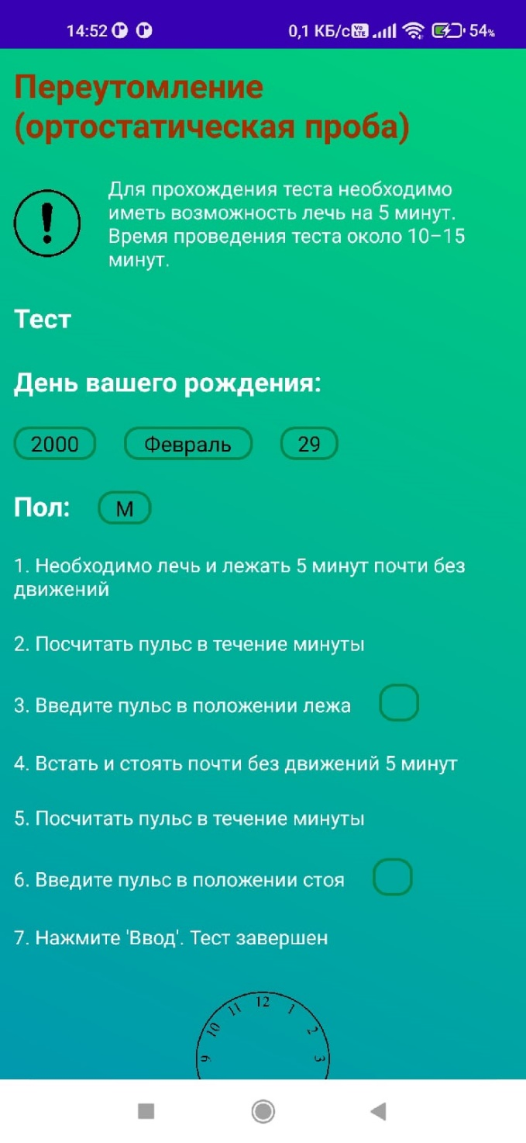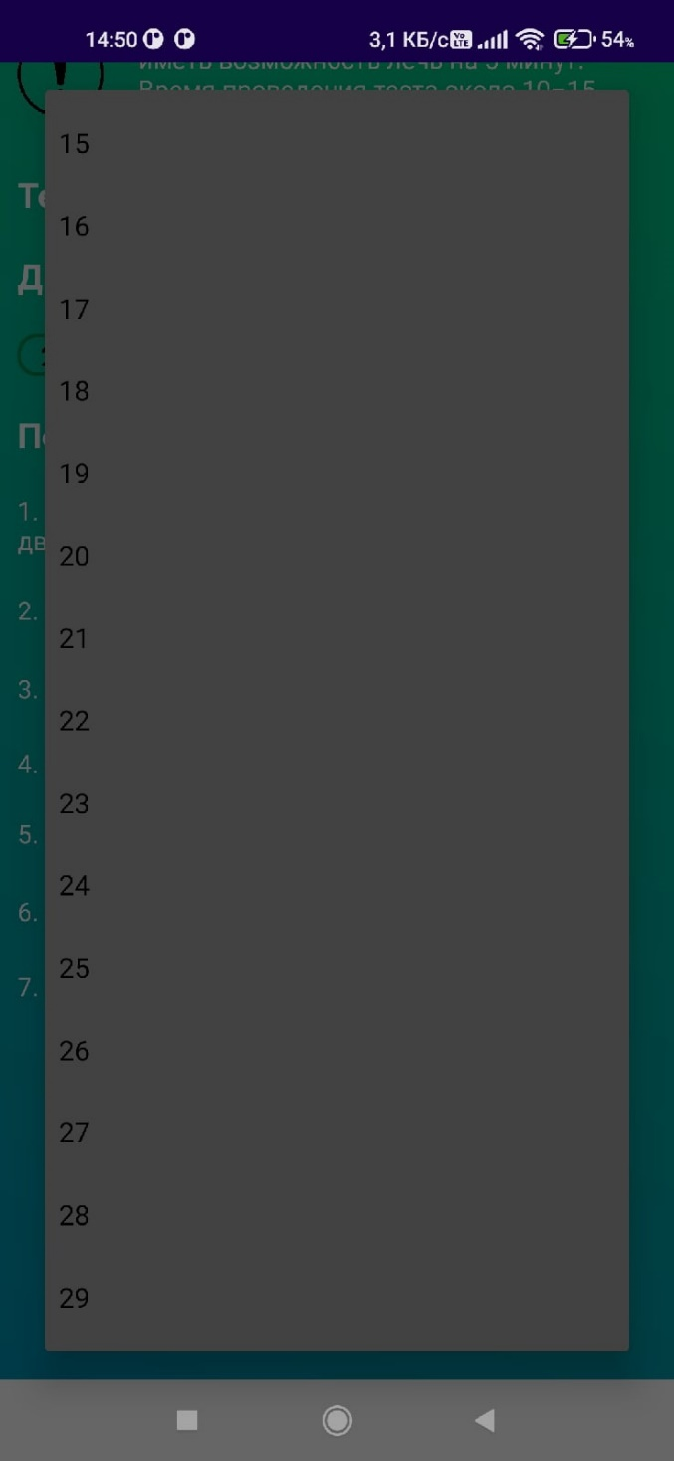

Демонстрация вариаций активити результата: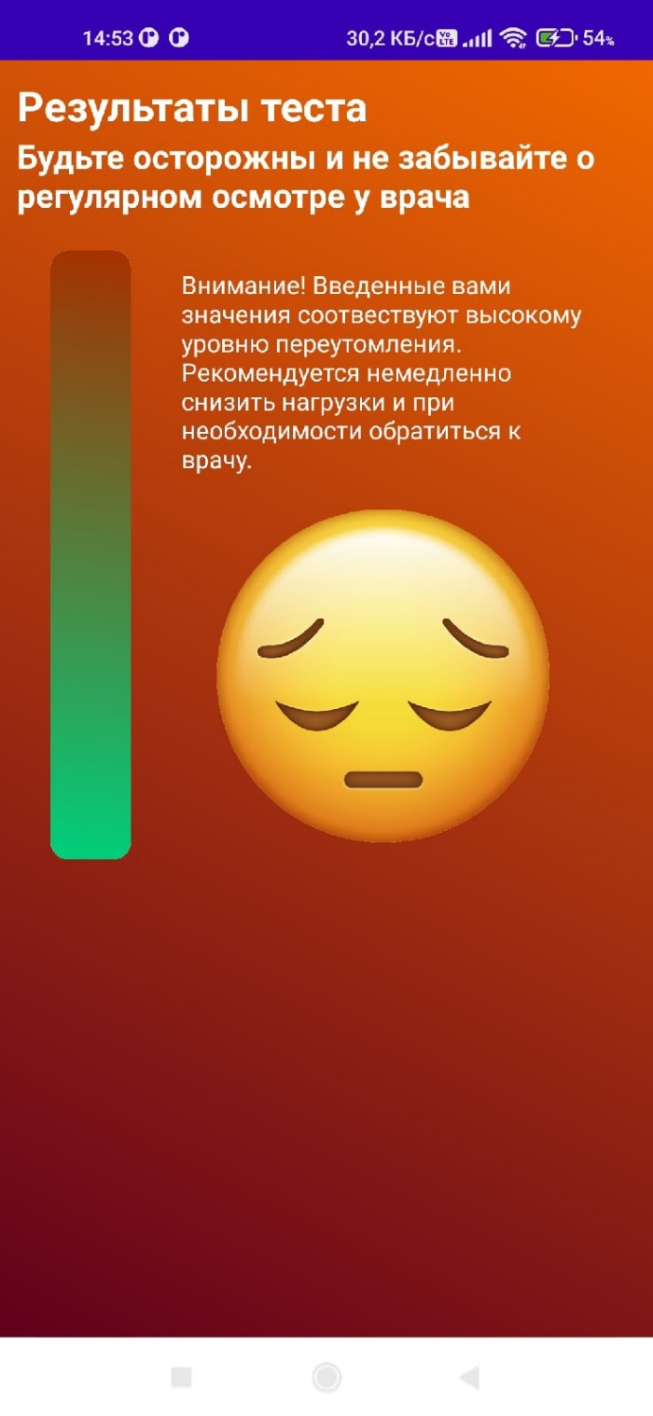

MainActiviry.java:

package *com.example.controlwork*;  
  
import *android.annotation.SuppressLint*;  
import *android.app.DatePickerDialog*;  
import *android.content.Intent*;  
import *android.os.Bundle*;  
import *android.text.format.DateUtils*;  
import *android.view.View*;  
import *android.widget.*AdapterView;  
import *android.widget.ArrayAdapter*;  
import *android.widget.Button*;  
import *android.widget.DatePicker*;  
import *android.widget.EditText*;  
import *android.widget.Spinner*;  
import *android.widget.TextView*;  
import *android.widget.Toast*;  
  
import *androidx.appcompat.app.AppCompatActivity*;  
  
import *java.io.BufferedReader*;  
import *java.io.InputStreamReader*;  
import *java.io.*OutputStream;  
import *java.net.*HttpURLConnection;  
import *java.net.URL*;  
import *java.nio.charset.StandardCharsets*;  
import *java.util.*Calendar;  
import *java.util.Date*;  
  
public class *MainActivity* extends *AppCompatActivity* implements *View*.*OnClickListener*, AdapterView.*OnItemSelectedListener*, *DatePickerDialog*.*OnDateSetListener* {  
  
 *Spinner* spSex;  
 *ArrayAdapter*<*String*> aaSex;  
  
 *EditText* etLying;  
 *EditText* etStanding;  
  
 *Button* btnComplete;  
  
 *String*[] sexes = {"М", "Ж"};  
  
 int day;  
 int month;  
 int year;  
 int sex;  
  
 int lyingPulse;  
 int standingPulse;  
  
 Calendar calendar;  
 *TextView* tvDate;  
  
 *@Override* protected void onCreate(*Bundle savedInstanceState*) {  
 super.onCreate(*savedInstanceState*);  
 setContentView(*R*.*layout*.activity_main);  
 setElements();  
 }  
  
 public void setTvDate(*View v*) {  
 *DatePickerDialog* datePickerDialog = new DatePickerDialog(this, this,  
 calendar.get(Calendar.YEAR),  
 calendar.get(Calendar.MONTH),  
 calendar.get(Calendar.DAY_OF_MONTH));  
 datePickerDialog.getDatePicker().setMaxDate(new Date().getTime());  
 datePickerDialog.show();  
 }  
  
 private void setInitialDateTime() {  
 tvDate.setText(*DateUtils*.*formatDateTime*(this,  
 calendar.getTimeInMillis(),  
 *DateUtils*.FORMAT_SHOW_DATE | *DateUtils*.FORMAT_SHOW_YEAR));  
 }  
  
  
 *@Override* public void onDateSet(*DatePicker view*, int *numberOfYear*, int *monthOfYear*, int *dayOfMonth*) {  
 calendar.set(Calendar.YEAR, *numberOfYear*);  
 calendar.set(Calendar.MONTH, *monthOfYear*);  
 calendar.set(Calendar.DAY_OF_MONTH, *dayOfMonth*);  
 year = *numberOfYear*;  
 month = *monthOfYear* + 1;  
 day = *dayOfMonth*;  
 setInitialDateTime();  
 }  
  
 *@Override* public void onItemSelected(AdapterView<?> *adapterView*, *View view*, int *i*, long *l*) {  
 sex = *i* + 1;  
 }  
  
  
 *@Override* public void onNothingSelected(AdapterView<?> *adapterView*) {  
 }  
  
  
 *@SuppressLint*("NonConstantResourceId")  
 *@Override* public void onClick(*View view*) {  
 switch (*view*.getId()) {  
 case *R*.*id*.tvDate:  
 setTvDate(tvDate);  
 break;  
 case *R*.*id*.complete_button:  
 if (!checkPulse()) {  
 changeBorder(*R*.*drawable*.circle_corners_incorrect);  
 *Toast*.*makeText*(this, *StringStorage*.INCORRECT_INPUT, *Toast*.LENGTH_SHORT).show();  
 } else {  
 getPulse();  
 getResponse();  
 }  
 }  
 }  
  
 public void setElements() {  
 spSex = findViewById(*R*.*id*.spinner_sex);  
 aaSex = new ArrayAdapter<>(this, *android.R*.*layout*.simple_spinner_item, sexes);  
 aaSex.setDropDownViewResource(*android.R*.*layout*.simple_spinner_dropdown_item);  
 spSex.setAdapter(aaSex);  
 spSex.setSelection(0);  
 spSex.setOnItemSelectedListener(this);  
  
 etLying = findViewById(*R*.*id*.lying_pulse);  
 etStanding = findViewById(*R*.*id*.standing_pulse);  
  
 btnComplete = findViewById(*R*.*id*.complete_button);  
 btnComplete.setOnClickListener(this);  
  
 calendar = Calendar.*getInstance*();  
 tvDate = findViewById(*R*.*id*.tvDate);  
 tvDate.setOnClickListener(this);  
 setInitialDateTime();  
 }  
  
 public boolean checkPulse() {  
 return isInteger(etLying.getText().toString()) && isInteger(etStanding.getText().toString());  
 }  
  
 public boolean isInteger(*String string*) {  
 try {  
 *Integer*.*parseInt*(*string*);  
 return true;  
 } catch (*Exception e*) {  
 return false;  
 }  
 }  
  
 public void changeBorder(int *drawable*) {  
 etLying.setBackgroundResource(*drawable*);  
 etStanding.setBackgroundResource(*drawable*);  
 }  
  
 public void getPulse() {  
 lyingPulse = *Integer*.*parseInt*(etLying.getText().toString());  
 standingPulse = *Integer*.*parseInt*(etStanding.getText().toString());  
 }  
  
 public void getResponse() {  
 new Thread(() -> {  
 try {  
 *String* parameters = "day=" + day + "&month=" + month + "&year=" + year + "&sex=" + sex + "&m1=" + lyingPulse + "&m2=" + standingPulse;  
  
 *URL* url = new URL(*StringStorage*.LINK);  
  
 HttpURLConnection connection = (HttpURLConnection) url.openConnection();  
  
 connection.setRequestMethod(*StringStorage*.METHOD);  
 connection.setRequestProperty(*StringStorage*.HOST_KEY, *StringStorage*.HOST_VALUE);  
 connection.setRequestProperty(*StringStorage*.CONNECTION_KEY, *StringStorage*.CONNECTION_VALUE);  
 connection.setRequestProperty(*StringStorage*.CACHE_KEY, *StringStorage*.CACHE_VALUE);  
 connection.setRequestProperty(*StringStorage*.DNT_KEY, *StringStorage*.DNT_VALUE);  
 connection.setRequestProperty(*StringStorage*.UPGRADE_KEY, *StringStorage*.UPGRADE_VALUE);  
 connection.setRequestProperty(*StringStorage*.ACCEPT_KEY, *StringStorage*.ACCEPT_VALUE);  
 connection.setRequestProperty(*StringStorage*.ENCODING_KEY, *StringStorage*.ENCODING_VALUE);  
 connection.setRequestProperty(*StringStorage*.LANGUAGE_KEY, *StringStorage*.LANGUAGE_VALUE);  
 connection.setRequestProperty(*StringStorage*.TYPE_KEY, *StringStorage*.TYPE_VALUE);connection.setRequestProperty(*StringStorage*.LENGTH_KEY, *String*.*valueOf*(parameters.length()));  
 connection.setDoInput(*StringStorage*.INPUT);  
 connection.setDoOutput(*StringStorage*.OUTPUT);  
 connection.connect();  
  
 OutputStream outputStream = connection.getOutputStream();  
 outputStream.write(parameters.getBytes(*StandardCharsets*.UTF_8));  
 outputStream.close();  
  
 *BufferedReader* bufferedReader = new BufferedReader(new InputStreamReader(connection.getInputStream()));  
 *String* data;  
 *StringBuilder* response = new StringBuilder();  
  
 while ((data = bufferedReader.readLine()) != null) {  
 response.append(data);  
 }  
 bufferedReader.close();  
  
 *String* parsedResponse = new String(response.toString().getBytes(), *StandardCharsets*.UTF_8).replaceAll(*StringStorage*.RESPONSE_PATTERN, "");  
 *Intent* intent = new Intent(this, *ResultActivity*.class);  
 intent.putExtra(*StringStorage*.INTENT_KEY, parsedResponse);  
 startActivity(intent);  
 } catch (*Exception exception*) {  
 *exception*.printStackTrace();  
 }  
 }).start();  
 }  
}

ResultActivity.java:

package *com.example.controlwork*;  
  
import *android.os.Bundle*;  
import *android.widget.ImageView*;  
import *android.widget.ProgressBar*;  
import *android.widget.ScrollView*;  
import *android.widget.TextView*;  
  
import *androidx.appcompat.app.AppCompatActivity*;  
  
public class *ResultActivity* extends *AppCompatActivity* {  
 *ScrollView* scroll_view;  
 *TextView* heading;  
 *TextView* advice;  
 *ProgressBar* progress_bar;  
 *TextView* description;  
 *ImageView* icon;  
  
 *String* result;  
  
 *@Override* protected void onCreate(*Bundle savedInstanceState*) {  
 super.onCreate(*savedInstanceState*);  
 setContentView(*R*.*layout*.activity_result);  
 result = getIntent().getExtras().getString(*StringStorage*.INTENT_KEY);  
  
 scroll_view = findViewById(*R*.*id*.scroll_view);  
 heading = findViewById(*R*.*id*.heading);  
 advice = findViewById(*R*.*id*.advice);  
 progress_bar = findViewById(*R*.*id*.progress_bar);  
 description = findViewById(*R*.*id*.description);  
 icon = findViewById(*R*.*id*.icon);  
 advice.setText(result);  
 heading.setTextColor(getResources().getColor(*R*.*color*.black));  
 switch (result) {  
 case *StringStorage*.GOOD_RESULT:  
 progress_bar.setProgress(90);  
 description.setText(*R*.*string*.good_results);  
 scroll_view.setBackgroundResource(*R*.*drawable*.gradient_green_to_blue);  
 icon.setImageResource(*R*.*drawable*.good_result);  
 break;  
 case *StringStorage*.MEDIUM_RESULT:  
 progress_bar.setProgress(55);  
 description.setText(*R*.*string*.medium_results);  
 scroll_view.setBackgroundResource(*R*.*drawable*.gradient_green_to_blue);  
 icon.setImageResource(*R*.*drawable*.good_result);  
 break;  
 case *StringStorage*.BAD_RESULT:  
 progress_bar.setProgress(20);  
 description.setText(*R*.*string*.bad_results);  
 scroll_view.setBackgroundResource(*R*.*drawable*.gradient_red_to_orange);  
 icon.setImageResource(*R*.*drawable*.bad_result);  
 break;  
 default:  
 progress_bar.setProgress(0);  
 description.setText(*R*.*string*.error_results);  
 scroll_view.setBackgroundResource(*R*.*drawable*.gradient_red_to_orange);  
 icon.setImageResource(*R*.*drawable*.bad_result);  
 break;  
 }  
 }  
}

StringStorage.java:

package *com.example.controlwork*;  
  
public class *StringStorage* {  
 final static *String* LINK = "http://abashin.ru/cgi-bin/ru/tests/burnout";  
 final static *String* METHOD = "POST";  
 final static *String* HOST_KEY = "Host";  
 final static *String* HOST_VALUE = "abashin.ru";  
 final static *String* CONNECTION_KEY = "Connection";  
 final static *String* CONNECTION_VALUE = "close";  
 final static *String* CACHE_KEY = "Cache-Control";  
 final static *String* CACHE_VALUE = "max-age=0";  
 final static *String* DNT_KEY = "DNT";  
 final static *String* DNT_VALUE = "1";  
 final static *String* UPGRADE_KEY = "Upgrade-Insecure-Requests";  
 final static *String* UPGRADE_VALUE = "1";  
 final static *String* ACCEPT_KEY = "Accept";  
 final static *String* ACCEPT_VALUE = "text/html,application/xhtml+xml,application/xml;q=0.9,image/avif,image/webp,image/apng,*/*;q=0.8,application/signed-exchange;v=b3;q=0.9";  
 final static *String* ENCODING_KEY = "Accept-Encoding";  
 final static *String* ENCODING_VALUE = "deflate";  
 final static *String* LANGUAGE_KEY = "Accept-Language";  
 final static *String* LANGUAGE_VALUE = "ru-RU,ru;q=0.9,en-US;q=0.8,en;q=0.7";  
 final static *String* TYPE_KEY = "Content-Type";  
 final static *String* TYPE_VALUE = "application/x-www-form-urlencoded";  
 final static *String* LENGTH_KEY = "Content-Type";  
 final static boolean INPUT = true;  
 final static boolean OUTPUT = true;  
  
 final static *String* INCORRECT_INPUT = "Неверный ввод";  
 final static *String* RESPONSE_PATTERN = "<.*?>";  
 final static *String* INTENT_KEY = "result";  
  
  
 final static *String* GOOD_RESULT = "Введенные значения соответствуют отсутствию переутомления.";  
 final static *String* MEDIUM_RESULT = "Введенные значения соответствуют небольшому переутомлению. Рекомендуется снижение нагрузки.";  
 final static *String* BAD_RESULT = "Введенные значения соответствуют высокому уровню переутомления. Рекомендуется снижение нагрузки или отпуск.";  
  
}

activity_main.xml:

<?xml version="1.0" encoding="utf-8"?>  
<LinearLayout xmlns:android="http://schemas.android.com/apk/res/android"  
 xmlns:tools="http://schemas.android.com/tools"  
 android:layout_width="match_parent"  
 android:layout_height="match_parent"  
 android:orientation="vertical"  
 tools:context=".MainActivity">  
  
 <ScrollView  
 android:layout_width="wrap_content"  
 android:layout_height="wrap_content"  
 tools:ignore="UselessParent">  
  
 <LinearLayout  
 android:layout_width="wrap_content"  
 android:layout_height="wrap_content"  
 android:background="@drawable/gradient_green_to_blue"  
 android:orientation="vertical">  
  
 <TextView  
 android:id="@+id/tvHeading"  
 style="@style/main_heading"  
 android:layout_width="wrap_content"  
 android:layout_height="wrap_content"  
 android:layout_margin="10dp"  
 android:text="@string/heading" />  
  
 <LinearLayout  
 android:layout_width="wrap_content"  
 android:layout_height="wrap_content"  
 android:orientation="horizontal"  
 tools:ignore="UseCompoundDrawables">  
  
 <ImageView  
 android:layout_width="50dp"  
 android:layout_height="match_parent"  
 android:layout_margin="10dp"  
 android:contentDescription="@string/important_information"  
 android:src="@drawable/exclamation" />  
  
 <TextView  
 style="@style/text"  
 android:layout_width="wrap_content"  
 android:layout_height="wrap_content"  
 android:layout_margin="10dp"  
 android:text="@string/description" />  
 </LinearLayout>  
  
 <TextView  
 style="@style/heading"  
 android:layout_width="wrap_content"  
 android:layout_height="wrap_content"  
 android:layout_margin="10dp"  
 android:text="@string/test" />  
  
 <TextView  
 style="@style/heading"  
 android:layout_width="wrap_content"  
 android:layout_height="wrap_content"  
 android:layout_margin="10dp"  
 android:text="@string/birthday" />  
  
 <TextView  
 android:id="@+id/tvDate"  
 style="@style/text"  
 android:layout_width="wrap_content"  
 android:layout_height="wrap_content"  
 android:text="@string/set_date" />  
  
 <LinearLayout  
 android:layout_width="wrap_content"  
 android:layout_height="wrap_content"  
 android:orientation="horizontal">  
  
 <TextView  
 style="@style/heading"  
 android:layout_width="wrap_content"  
 android:layout_height="wrap_content"  
 android:layout_margin="10dp"  
 android:text="@string/sex" />  
  
 <Spinner  
 android:id="@+id/spinner_sex"  
 style="@style/spinner_correct"  
 android:layout_width="wrap_content"  
 android:layout_margin="10dp" />  
  
 </LinearLayout>  
  
 <TextView  
 style="@style/text"  
 android:layout_width="wrap_content"  
 android:layout_height="wrap_content"  
 android:text="@string/step_1" />  
  
 <TextView  
 style="@style/text"  
 android:layout_width="wrap_content"  
 android:layout_height="wrap_content"  
 android:text="@string/step_2" />  
  
 <LinearLayout  
 android:layout_width="wrap_content"  
 android:layout_height="wrap_content"  
 android:orientation="horizontal">  
  
 <TextView  
 style="@style/text"  
 android:layout_width="wrap_content"  
 android:layout_height="wrap_content"  
 android:text="@string/step_3" />  
  
 <EditText  
 android:id="@+id/lying_pulse"  
 android:layout_width="wrap_content"  
 android:layout_height="wrap_content"  
 android:layout_margin="10dp"  
 android:autofillHints="Пульс"  
 android:background="@drawable/circle_corners_correct"  
 android:inputType="numberDecimal"  
 android:minWidth="30dp"  
 android:textColor="@color/black"  
 tools:ignore="LabelFor" />  
 </LinearLayout>  
  
  
 <TextView  
 style="@style/text"  
 android:layout_width="wrap_content"  
 android:layout_height="wrap_content"  
 android:text="@string/step_4" />  
  
 <TextView  
 style="@style/text"  
 android:layout_width="wrap_content"  
 android:layout_height="wrap_content"  
 android:text="@string/step_5" />  
  
 <LinearLayout  
 android:layout_width="wrap_content"  
 android:layout_height="wrap_content"  
 android:orientation="horizontal">  
  
 <TextView  
 style="@style/text"  
 android:layout_width="wrap_content"  
 android:layout_height="wrap_content"  
 android:text="@string/step_6" />  
  
 <EditText  
 android:id="@+id/standing_pulse"  
 android:layout_width="wrap_content"  
 android:layout_height="wrap_content"  
 android:layout_margin="10dp"  
 android:autofillHints="Пульс"  
 android:background="@drawable/circle_corners_correct"  
 android:inputType="numberDecimal"  
 android:minWidth="30dp"  
 android:textColor="@color/black"  
 tools:ignore="LabelFor" />  
 </LinearLayout>  
  
 <TextView  
 style="@style/text"  
 android:layout_width="wrap_content"  
 android:layout_height="wrap_content"  
 android:text="@string/step_7" />  
  
 <RelativeLayout  
 android:layout_width="match_parent"  
 android:layout_height="wrap_content"  
 android:padding="10dp">  
  
 <ImageView  
 android:id="@+id/clock_face"  
 android:layout_width="100dp"  
 android:layout_height="100dp"  
 android:layout_centerHorizontal="true"  
 android:layout_margin="10dp"  
 android:contentDescription="@string/clock_face_description"  
 android:src="@drawable/clock_face" />  
  
 <Button  
 android:id="@+id/complete_button"  
 android:layout_width="wrap_content"  
 android:layout_height="wrap_content"  
 android:layout_below="@+id/clock_face"  
 android:layout_centerInParent="true"  
 android:layout_marginStart="10dp"  
 android:layout_marginTop="10dp"  
 android:layout_marginEnd="10dp"  
 android:layout_marginBottom="10dp"  
 android:background="@drawable/gradient_green_to_cyan"  
 android:text="@string/complete" />  
 </RelativeLayout>  
  
  
 </LinearLayout>  
 </ScrollView>  
</LinearLayout>

result_activity.xml:

<?xml version="1.0" encoding="utf-8"?>  
<ScrollView xmlns:android="http://schemas.android.com/apk/res/android"  
 xmlns:tools="http://schemas.android.com/tools"  
 android:id="@+id/scroll_view"  
 android:layout_width="match_parent"  
 android:layout_height="match_parent"  
 android:background="@drawable/gradient_red_to_orange"  
 android:padding="10dp">  
  
 <RelativeLayout  
 android:layout_width="match_parent"  
 android:layout_height="wrap_content">  
  
 <TextView  
 android:id="@+id/heading"  
 style="@style/main_heading"  
 android:layout_width="wrap_content"  
 android:layout_height="wrap_content"  
 android:layout_alignParentStart="true"  
 android:text="@string/results" />  
  
 <TextView  
 android:id="@+id/advice"  
 style="@style/heading"  
 android:layout_width="wrap_content"  
 android:layout_height="wrap_content"  
 android:layout_below="@+id/heading"  
 android:layout_alignParentStart="true" />  
  
  
 <LinearLayout  
 android:layout_width="match_parent"  
 android:layout_height="wrap_content"  
 android:layout_below="@+id/advice"  
 android:layout_centerHorizontal="true"  
 android:orientation="horizontal"  
 android:padding="10dp">  
  
 <ProgressBar  
 android:id="@+id/progress_bar"  
 style="?android:attr/progressBarStyleHorizontal"  
 android:layout_width="wrap_content"  
 android:layout_height="match_parent"  
 android:layout_margin="10dp"  
 android:progressDrawable="@drawable/progress_bar" />  
  
 <LinearLayout  
 android:layout_width="match_parent"  
 android:layout_height="wrap_content"  
 android:layout_margin="10dp"  
 android:orientation="vertical"  
 tools:ignore="UseCompoundDrawables">  
  
 <TextView  
 android:id="@+id/description"  
 style="@style/text"  
 android:layout_width="wrap_content"  
 android:layout_height="wrap_content"  
 android:layout_marginBottom="10dp" />  
  
 <ImageView  
 android:id="@+id/icon"  
 android:layout_width="wrap_content"  
 android:layout_height="200dp"  
 android:layout_margin="10dp"  
 android:contentDescription="@string/state" />  
 </LinearLayout>  
 </LinearLayout>  
 </RelativeLayout>  
</ScrollView>

AndroidManifest.xml:

<?xml version="1.0" encoding="utf-8"?>  
<manifest xmlns:android="http://schemas.android.com/apk/res/android"  
 package="com.example.controlwork">  
  
 <uses-permission android:name="android.permission.INTERNET" />  
 <application  
 android:allowBackup="true"  
 android:icon="@mipmap/ic_launcher"  
 android:label="@string/app_name"  
 android:roundIcon="@mipmap/ic_launcher_round"  
 android:supportsRtl="true"  
 android:theme="@style/Theme.ControlWork"  
 android:usesCleartextTraffic="true">  
 <activity  
 android:name=".ResultActivity"  
 android:exported="true" />  
 <activity  
 android:name=".MainActivity"  
 android:exported="true">  
 <intent-filter>  
 <action android:name="android.intent.action.MAIN" />  
  
 <category android:name="android.intent.category.LAUNCHER" />  
 </intent-filter>  
 </activity>  
 </application>  
  
</manifest>